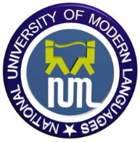**NATIONAL UNIVERSITY OF MODERN LANGUAGES**

**Faculty of Engineering and Computer Sciences  
BSSE (Morning)- Mid Term Examination – Spring 2021**

|  |  |
| --- | --- |
| **Paper: Pakistan Studies**  **Time Allowed: 2 hours** | **Total Marks : 30 Roll # ________** |

**Instructions:**

* Attempt all questions

Q 1. What was the role of Sir Syed Ahmad Khan and Allama Iqbal in elevation the Muslim Community Educationally and Intelectually? Explain in your own words?

(10)

Q 2. Explain the details of military expeditions launched by Muslim dynasties to annex the Indian soils and furthermore what were the main factors led towards the creation of Muslim nationalism? Critically analyze. (10)